

**Mini Project Report**

On

**“SMART AMBIENCE MONITORING SYSTEM”**

# **Submitted by**

**Rakshit Chawla (PC29)**

**Rijul Sherathia (PC30)**

**Rahul Arya (PC47)**

**Sayali Parulekar (PC11)**

**Roshni Bhirad (PC8)**

**Smit Kesarkar (PC50)**

**Shruti Gupta (PC44)**

**Sanchita Biswas (PC17)**

**Under the guidance of**

**Prof. Aniket Ingavale**

**School of Computer Engineering and Technology**

**MIT World Peace University, Kothrud,**

**Pune 411 038, India**

### 

### **SCHOOL OF COMPUTER ENGINEERING AND TECHNOLOGY**

# CERTIFICATE

This is to certify that

**Rakshit Chawla (PC29)**

**Rijul Sherathia (PC30)**

**Rahul Arya (PC47)**

**Sayali Parulekar (PC11)**

**Roshni Bhirad (PC8)**

**Smit Kesarkar (PC50)**

**Shruti Gupta (PC44)**

**Sanchita Biswas (PC17)**

## Of T. Y. B. Tech. successfully completed Mini Project Report in

## **“Smart ambience monitoring system”**

To my satisfaction and submitted the same during academic year 2019-20 Trimester VII as part of Embedded and Internet of Things Laboratory subject.

**Prof. Aniket Ingavale Dr. M.V.Bedekar**

**(Mini Project Guide) (Program Head)**

**Place:** School of Computer Engineering and Technology, MIT-WPU, Pune

**Date: 27/09/2019**

**Table of Contents**

|  |  |  |  |
| --- | --- | --- | --- |
|  | **Topic** | | **Page No.** |
| **1** | **Introduction** | | **4** |
| **2** | **Related Work** | | **5** |
|  | 2.1 | Literature Survey /Analysis of existing methods | 5 |
| **3** | **Proposed Work** | | **6** |
|  | 3.1 | Problem Statement | 6 |
|  | 3.2 | Social Relevance | 6 |
|  | 3.3 | Architecture/Model | 6 |
|  | 3.4 | Hardware and Software Requirement | 6 |
|  | 3.5 | Results obtained (with Screen shots of Results) | 6 |
| **5** | **Conclusion** | | **7** |
| **6** | **References** | | **7** |

**ABSTRACT**

In the cutting edge world, the advances have definitely grown, yet at the same time the cleanliness in our nation is under risk. The purpose of this project is to deliver clean and hygienic living space. In our country, our government has introduced the scheme called “Swachh Bharat” (Clean India). Keeping the surroundings uncontaminated is the one of the objective of Clean India scheme. This report can be helpful to encourage the clean India project. In future, it might prove a significant part in clean India scheme. In an Existing system, they are focused only on identifying the dirt in the toilets. In our proposed system, we have determined on keeping clean atmosphere along with observing the sweeper’s working activities. It can dodge many syndromes. It may create the consciousness amongst people about ambience management and administration. Therefore, our development is cleanliness monitoring system.

**INTRODUCTION**

In our country, people do not have enough knowledge of proper hygiene. This leads to several diseases, such as Malaria, Hepatitis, Flu, Cholera, Typhoid, etc. Hence we introduced the IOT based project. It is introduced to use and maintain the ambience of a room in clean and hygienic way. The system automatically calls for any sweepers if needed and is fully automated to function in any kind of environment. The project is based on IoT concepts using different sensors. Using the materials, we are trying to provide the clean environment and provide better living space to people with minimal effort. This will create awareness among the people and help develop a healthy lifestyle.

**RELATED WORK**

**LITERATURE SURVEY**

Kitisak Osathanunkul, Kittikorn Hantrakul, Part Pramokcho (2017) have proposed “Configurable automatic smart urinal flusher based on MQTT”. This paper examines one probable way to cut the wastage of clean water used in a public toilet. The system uses MQTT in gathering, governing, powerful and correcting the system. The results in the test environment show that flushing for 2.5 seconds is enough to satisfy most users while wasting as less water as possible.

There are two parts involved here:

1. Automatic Flusher Part (AFP)

2. Server

The AFP detects if there is an object in front of its infrared sensor. When a user stands in front of the urinal, an infrared sensor can detect the user. If the user keeps staying in front of the sensor for 3 seconds continuously, it is considered that a user is currently using a urinal. After the urinal has been flushed AFP unit also sends a MQTT message about it usage data to the server part.

In server part, it receives the usage data from AFP unit. The usage data will be stored into a database for a future use.

A. D. Kadge, A. K. Varute, P. G. Patil, P. R. Belukhi (2016) proposed an “Automatic sewage disposal system for train”. Indian Railways have 114,500 km of total track over a route of 65000 km and 7500 stations. While travelling by train everyone expects healthy and hygienic surroundings. It feels uncomfortable due to the waste on the platform and the allied foul smell.

**PROPOSED WORK**

**PROBLEM STATEMENT**

To configure an all-in-one IoT-based ambience monitoring system, applicable to commercial environments with extensions for hygiene monitoring and analysis.

**SOCIAL RELEVANCE**

* Research indicates that people spend 90% of the time indoors. Inadequate ventilation, release of gases or particles into the air are two primary reasons for health issues.
* With the increase in ignorance of people towards cleanliness, it is more than necessary to have a measure that can motivate us, and at the same time help us to maintain a composed environment.

**ARCHITECTURE/MODEL**

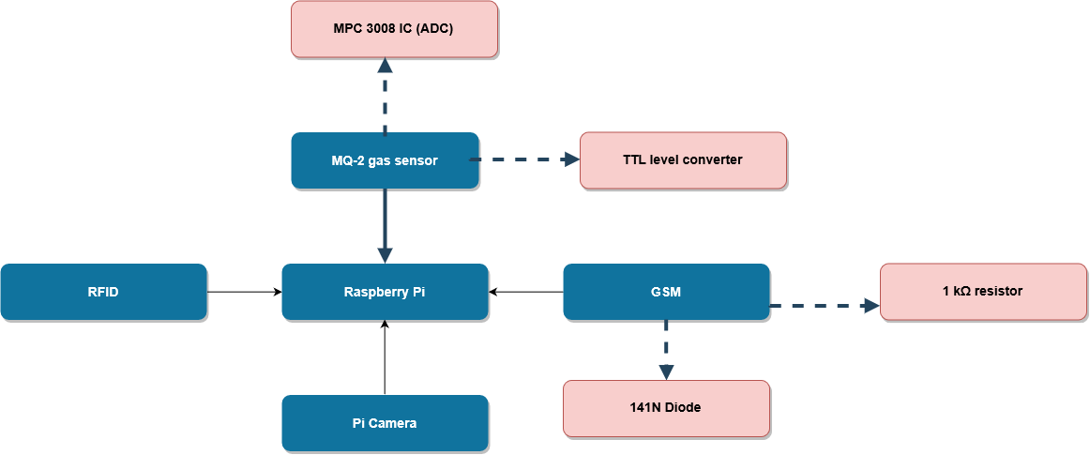

**HARDWARE AND SOFTWARE REQUIREMENTS**

1. MQ2 gas sensor
2. Raspberry pi kit
3. RFID reader
4. Pi Camera
5. GSM modem
6. Breadboard
7. Jumper wires
8. TTL level converter
9. MPC 3008 IC (ADC)

**RESULTS OBTAINED**

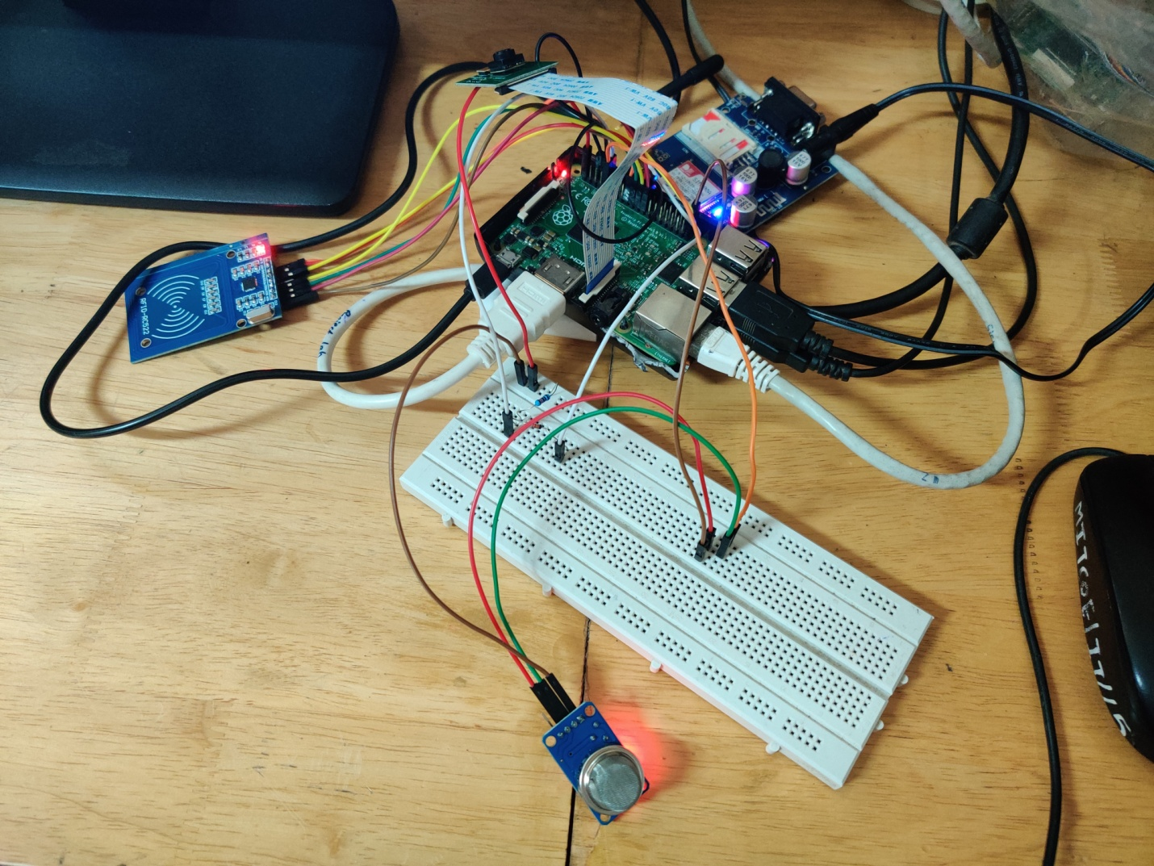

Taking 1st Image  
Taking 2nd Image  
SMOKE DETECTED!!  
Dirt Detected  
Text mode enabled...  
sending message ...  
message sent ...  
looking for cards  
press ctrl+c to stop  
217856679632  
RIJUL                                           
looking for cards  
217856679632  
RIJUL                                            
Worker completed the work

**CONCLUSION**

This project aims to spread awareness about workspace hygiene. It employs IoT, using it for disease prevention. Additionally, the smart monitoring helps regulate cleanliness and hygiene in a commercial environment, over a period of time. This prototype can be further extended to larger-scale use cases, such as assembly-line regulation and space hygiene.

**REFERENCES**

1. [https://www.raspberrypi.org](https://www.raspberrypi.org/)
2. [https://www.tutorialspoint.com](https://www.tutorialspoint.com/)
3. [https://www.geeksforgeeks.org](https://www.geeksforgeeks.org/)
4. [https://electronicsforu.com](https://electronicsforu.com/)
5. [https://www.pantechsolutions.net](https://www.pantechsolutions.net/)
6. [https://www.skyfilabs.com](https://www.skyfilabs.com/)